



AMA
AKSHAY MAHESHWARI AND ASSOCIATES
“Where Global Standards meet
Professional Precision”
ACTIVE CLIENTS
GSTIN NO:
AQKPM9503A1Z
23
6
ESTABLISHED
PRINCIPAL PRACTICE ADDRESS:
G(1), Scheme No. 71, Gumasta Nagar, Indore, IND
28
—
C
H
A
R
T
E
R
E
D

A
C
C
O
U
N
T
A
N
T
S

&

A
D
V
I
S
O
R
Y
Global Advisory.
Indian Expertise.
INDORE, INDIA · INTERNATIONAL PRACTICE
Bridging Indian regulatory intelligence with global
standards — serving cross-border businesses, foreign
investors, and multinational enterprises.
8+
Years
YEARS OF PRACTICE
250+
2018
ABOUT THE FIRM AMA
Our Story & Philosophy AKSHAY MAHESHWARI AND ASSOCIATES


OUR CORE MISSION
Founded in 2018, Akshay Maheshwari and Associates (AMA) is a
distinguished Chartered Accountancy and international advisory
practice headquartered in Indore, India — the commercial capital
of Central India.
Over 5+ years of focused practice, AMA has evolved into a sophisticated advisory firm
trusted
by
cross-border
businesses,
foreign
subsidiaries,
domestic
corporates,
and
high-growth enterprises.
We combine technical regulatory mastery, commercial pragmatism, and sector-specific
insight. Our practice brings the rigor of Big-4 audit methodology with the responsive
agility and dedicated relationship mindset of a high-end boutique advisory firm.
To be amongst the most highly respected professional advisory firms in India — where clients
from across the globe come for the peace of mind that their financial, compliance, and strategic
interests are being managed with absolute intelligence, precision, and integrity.
CLIENT PARTNERSHIP
We
consider
ourselves
thought-partners,
not
simple
compliance
loggers. We study your underlying business operations to trigger true
cost-saving strategies.
STRATEGIC INNOVATION
We
embrace
cloud-native
ERPs,
automated
mis
dashboards
and
digital tax-law research systems to provide modern, forward-thinking
solutions.
PROFESSIONAL COMMITMENT
We
hold
ourselves
to
the
highest
global
standards.
Every
client
engagement
is
handled
with
absolute
financial
rigor,
timeliness
and commercial accountability.
INTEGRITY & CONFIDENTIALITY
Client trust is our non-negotiable benchmark. We maintain complete
operational transparency, zero conflict of interest and absolute safe
data preservation.

AKSHAY MAHESHWARI AND ASSOCIATES · Chartered Accountants PAGE 02 OF 08

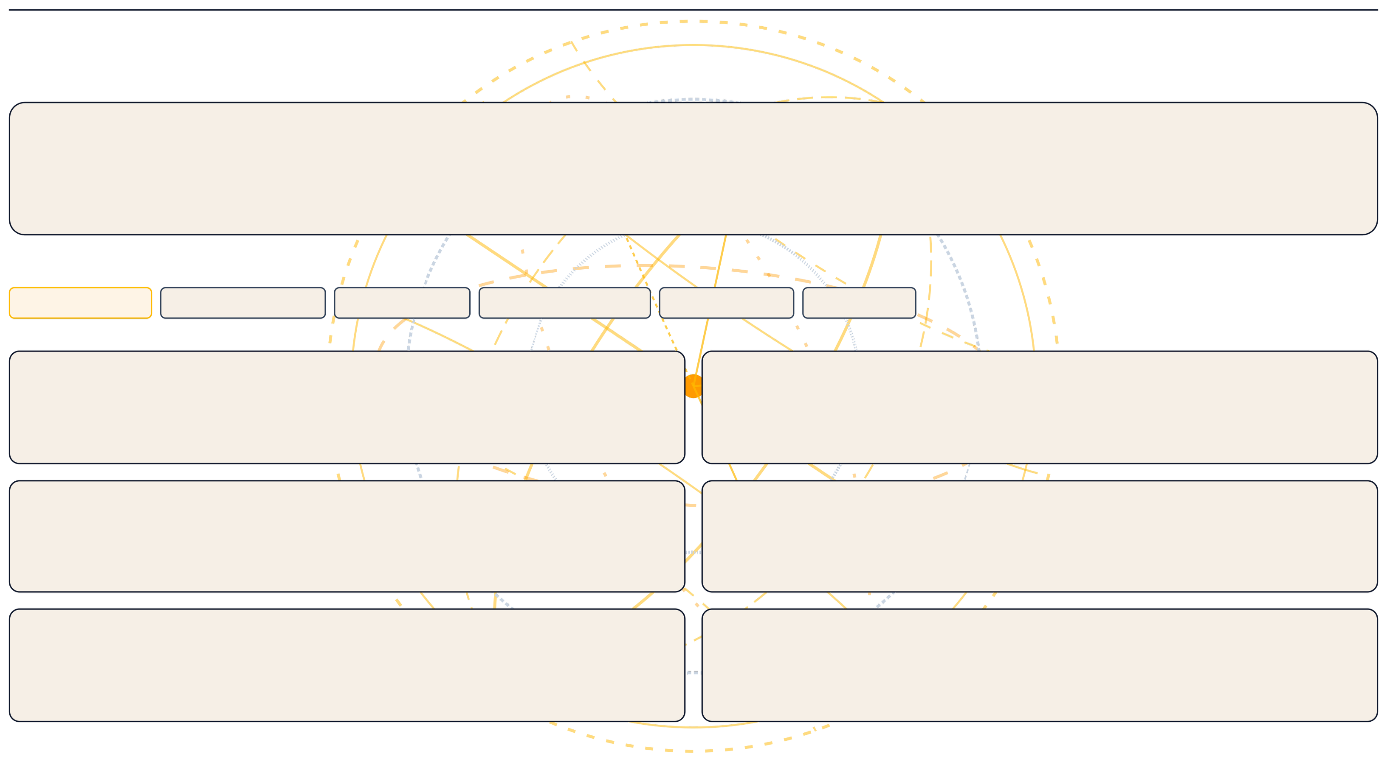
PRIMARY ACTIVE GEOGRAPHIES:
AKSHAY MAHESHWARI AND ASSOCIATES · Global Practice Profile
AMA
AKSHAY MAHESHWARI AND ASSOCIATES
PAGE 03 OF 08
INTERNATIONAL CAPABILITIES
Global Reach &
Cross-Border Advisory
SERVING CLIENTS ACROSS BORDERS
AMA delivers premium Indian advisory intelligence paired with global standards. We represent multi-jurisdictional corporations, foreign direct investors (FDI), and overseas
companies establishing key setups in India.
IND · INDIA (HQ)
USA · UNITED STATES
UAE · UAE / GCC
GBR · UNITED KINGDOM
SGP · SINGAPORE
CAN · CANADA
01
03
05
02
04
06
INDIA ENTRY ADVISORY
End-to-end support for foreign companies establishing India operations—entity
structuring, regulatory approvals, FEMA compliance, and ongoing governance.
IFRS / US GAAP REPORTING
Group reporting for Indian subsidiaries of global groups—IND AS to IFRS conversion,
policy harmonisation, and group pack preparation.
VIRTUAL ADVISORY SUPPORT
Cloud-enabled remote advisory for global businesses—real-time reporting, virtual
CFO, and responsive support across time zones.
TRANSFER PRICING
TP policy design, annual documentation, Form 3CEB preparation, and representation
before the Transfer Pricing Officer.
FEMA & RBI COMPLIANCE
Comprehensive FEMA management—FDI reporting, ODI filings, ECB documentation,
and liaison with authorised dealer banks and RBI.
CROSS-BORDER TAXATION
DTAA analysis, withholding tax optimisation, PE risk assessment, and international tax
structuring for India-linked cross-border cash flows.
SERVICE PORTFOLIO AMA
Our Capabilities — Part I AKSHAY MAHESHWARI AND ASSOCIATES

FUNCTION 01
FUNCTION 03
FUNCTION 02
FUNCTION 04
AUDIT & ASSURANCE

INTERNATIONAL TAXATION & FEMA

ACCOUNTING & BOOKKEEPING

TAXATION — DIRECT & INDIRECT

Cross-border advisory for global investors & foreign subsidiaries.

Audits that go beyond compliance — delivering actionable internal control insights.

IFRS-aligned records with real-time visibility.

Comprehensive, optimized tax strategy and compliance.

›
›
›
›
›
›
›
›
›
›
›
›
›
›
›
›
›
›
›
›
›
›
›
›
›
›
›

›
India-entry structuring—evaluation of Liaison Office, Branch Office, Project Office or subsidiary
structures.
FEMA compliance: inbound/outbound investment reporting, FC-GPR, FC-TRS, FLA returns and ODI
filings.
FDI advisory — sectoral caps, approval routes, pricing guidelines and downstream investment
regulations.
DTAA analysis and withholding tax rate optimisation for international remittances.
Form 15CA/15CB certifications for dividend repatriation, royalty payments and service fee outflows.
Transfer pricing strategy — policy design, benchmarking and annual TP documentation.
POEM regulations advisory and repatriation planning for NRI and foreign national investors.
Statutory Audit under the Companies Act,2013—risk assessment, substantive testing and issue
reporting for listed and unlisted entities.
Tax Audit under Section 44AB with detailed disallowance reporting and management commentary.
Internal audits, management audits and systems studies — evaluating process efficiency and internal
control robustness.
Bank audits including concurrent audits and statutory branch audits — credit review and fraud risk
assessment.
SOX Act documentation and internal control testing for US-listed multinational Indian subsidiaries.
Transfer pricing audits under Section 92E — benchmarking, comparables and Form 3CEB preparation.

Form 15CA/15CB certifications for cross-border remittances.
Full-service accounting using Tally ERP, Tally Prime, SAP, QuickBooks and advanced Excel.
Preparation and finalisation of Trading A/C, Profit & Loss A/C, and Balance Sheet.
IND AS conversion — technical advisory for companies transitioning from IGAAP.
Group reporting consolidation under IFRS and US GAAP for Indian entities within global groups.
Monthly MIS reporting — actual vs. budget analysis, variance commentary and cash flow statements.
Multi-currency account management, bank reconciliation and intercompany reconciliation.
SOP design for finance operations and internal billing.
Income tax return filing for Individuals, HUFs, Firms, LLPs and Companies including complex multi-source
structures.
Advance tax computation, TDS compliance management, e-TDS and TCS return filing across all sections.
Tax planning and restructuring advisory — optimising effective tax rates for domestic and cross-border
structures.
Representation before Income Tax Authorities — assessments, scrutiny, CIT(A) appeals and ITAT
proceedings.
End-to-end GST compliance: GSTR-1, GSTR-3B, GSTR-9, GSTR-9C — multi-state registration and
reconciliation.
Input tax credit optimisation, GST health checks and compliance reviews.
Representation before GST authorities during audits and departmental proceedings.

Audit · Taxation · Cross-Border Remittance · Bookkeeping Operations PAGE 04 OF 08 SERVICE PORTFOLIO AMA
Our Capabilities — Part II AKSHAY MAHESHWARI AND ASSOCIATES


FUNCTION 05
FUNCTION 07
FUNCTION 06
FUNCTION 08
VIRTUAL CFO & MIS REPORTING

BUSINESS ADVISORY SERVICES

CORPORATE LAW & CONSULTANCY

PAYROLL, FINANCIAL MODELLING & CONTROLS

Senior financial leadership delivered virtually and adaptively.

Strategic thought-partnership for corporate and entrepreneurial growth.

Compliance precision and robust internal controls risk mitigation.

End-to-end corporate structuring, statutory secretarial support & compliance.

›
›
›
›
›
›
›
›
›
›
›
›
›
›
›
›
›
›
›
›
›
›
›
›
›
›
Strategic financial analysis and commercial evaluation of investments, acquisitions and opportunities.
Financial modelling — three-statement models, DCF valuations, scenario and sensitivity analysis.
Feasibility studies and Detailed Project Reports (DPRs) for bank approvals and investor decks.
Business valuation — intrinsic value assessments for M&A, taxation and restructuring.
Profitability analysis, performance benchmarking and KPI design aligned to industry metrics.
SOP design and implementation across finance, operations and compliance functions.
Startup advisory — entity structuring, cap table management, ESOP design and fund raising compliance.
Embedded Virtual CFO — C-suite level financial oversight and board-level reporting for SMEs & foreign
subsidiaries.
Monthly MIS dashboard — P&L analysis, cost centre reporting, variance commentary and KPI scorecards.
13−
week rolling cash flow forecasting and working capital optimisation.
Budget preparation, quarterly reforecast and annual financial planning aligned to business strategy.
Investor reporting packages and board decks to international institutional standards.
ERP implementation support — chart of accounts design and reporting hierarchy configuration.
End-to-end payroll processing — TDS on salary, Form16 issuance, PF/ESI/PT compliance and EPFO
representation.
Expatriate payroll management — shadow payroll, DTAA benefits for foreign employees on Indian
assignment.
Integrated three-statement financial models with dynamic assumptions and scenario toggles.
Project finance modelling — debt sizing, DSCR analysis and IRR computation for lender engagement.
Working capital facility structuring — CMA data and bank-ready project reports for CC/OD/term loans.
Internal control framework design — COSO-based risk identification and IFC assessment.
Workflow design — process documentation, RACI matrix and SOP preparation for finance teams.
Business constitution advisory—Pvt Ltd, LLP, OPC, Section8, Trust, and Partnership..
Incorporation of Indian companies and JVs for foreign promoters — name reservation to commencement.
Annual compliance for Companies and LLPs — ROC filings, statutory registers and board documentation.
Mergers, acquisitions, de-mergers and corporate restructuring — structuring, valuation and
documentation.
Shareholders' and JV agreements review from a financial and compliance perspective.
Strike-off, winding up and liquidation advisory including NCLT filings and FEMA de-registration.

Business Advisory · Corporate Restructuring · Virtual CFO · internal Controls PAGE 05 OF 08 SECTOR EXPERIENCE AMA
Industries We Serve AKSHAY MAHESHWARI AND ASSOCIATES


HEALTHCARE
FINANCIAL SERVICES
AUTOMOBILE & DEALERSHIPS
REAL ESTATE & CONSTRUCTION
TECHNOLOGY & SAAS
E-COMMERCE & RETAIL
LOGISTICS & SUPPLY CHAIN
STARTUPS & VENTURE-BACKED
MANUFACTURING
PROFESSIONALS & HNIS
INTERNATIONAL TRADING
FOREIGN SUBSIDIARIES IN INDIA
RBI regulatory compliance, NBFC audit, FDI structuring,
investment fund advisory and tax compliance.
Dealer accounting, OEM reconciliation, workshop GST and
multi-location inventory management.
Project finance, GST on works contracts, land taxation, RERA
compliance and developer accounting.
Hospital accounting, GST on pharmaceutical supplies, medical
equipment depreciation and trust compliance.
Fundraising compliance, investor reporting, cap table
management and DPIIT recognition support.
Startup structuring, ESOP compliance, FEMA for overseas
subsidiaries and R&D incentives.
Multi-state GST, freight tax treatment, warehouse compliance
and fleet depreciation management.
Marketplace taxation, TCS/TDS on digital platforms, multi-state
GST and high-volume AP operations.
India-entry support, FEMA ongoing compliance, group
reporting, repatriation and RBI liaison.
Cost accounting, ITC optimisation, factory audit, transfer
pricing for component sourcing and inventory valuation.
Complex personal taxation, wealth structuring, succession
planning and trust management.
Import/export GST, customs duty advisory, foreign exchange
management and trade documentation.

Providing niche advisory and statutory accounting across complex global sectors PAGE 06 OF 08


EST: 2018
GST: 23AQKPM9503A1Z6
AMA
AKSHAY MAHESHWARI AND ASSOCIATES
PAGE 08 OF 08
GET IN TOUCH
Connect With
Our Team
CALL US
EMAIL
OFFICE LOCATION
+91 96694 29551
|
+91 81038 19950
akshaymaheshwariandassociates@gmail.com
Available for Zoom, Teams, & standard phone consultation.
All international queries receive response within 12 business
hours.
28
G(1), Scheme No. 71, Sector A, Gumasta
Nagar Main Road, Indore (MP) 452009, India
EXCELLENCE
TRUST
COMPETENCE

·

·

"Bridging domestic regulatory guidelines with international enterprise operations seamlessly."

